**EYE BALL CURSOR MOVEMENT USING OPENCV**

In this project we are instructing mouse cursor to change its location based on eye ball movement, in this application using OPENCV we will connect to webcam and then extract each frame from the webcam and pass to OPENCV to detect eye balls location. Once eye ball location detected then we can extract x and y coordinates of eye balls from OPENCV and then using python pyautogui API we can instruct mouse to change its current location to given eyeballs X and Y Coordinates. Below is the example to move mouse in python.

pyautogui.moveTo(int(data_x),int(data_y))

In above line moveTo function move cursor to given data_x and data_y location

To implement above concept we are using following modules

**Video Recording**: Using this module we will connect application to webcam using OPENCV built-in function called VideoCapture.

**Frame Extraction**: Using this module we will grab frames from webcam and then extract each picture frame by frame and send that frame to GazeTracking.

**GazeTracking**: Using this module we can detect eyeballs and the extract x and y coordinates of both left and right pupil.

**MoveCursor**: Using this module we will instruct mouse to change its current location to given new x and y location.

To stop video recording from webcam press ‘Esc’ key.

OpenCV is an artificial intelligence API available in python to perform various operation on as image recognition, face detection, eye detection/eye ball tracking and convert images to gray or coloured images etc. This API written in C++ languages and then make C++ functions available to call from python using native language programming. Steps involved in face detection using OpenCV.

Face Detection/Eye Detection Using OpenCV

images/videos such

This seems complex at first but it is very easy. Let me walk you through the entire process and you will feel the same.

Step 1: Considering our prerequisites, we will require an image, to begin with. Later we need to create a cascade classifier which will eventually give us the features of the face.

Step 2: This step involves making use of OpenCV which will read the image and the features file. So at this point, there are NumPy arrays at the primary data points.

All we need to do is to search for the row and column values of the face NumPy N dimensional array. This is the array with the face rectangle coordinates.

Step 3: This final step involves displaying the image with the rectangular face box.

Screen shots

To run this project double click on ‘run.bat’ file to get below webcam screen.

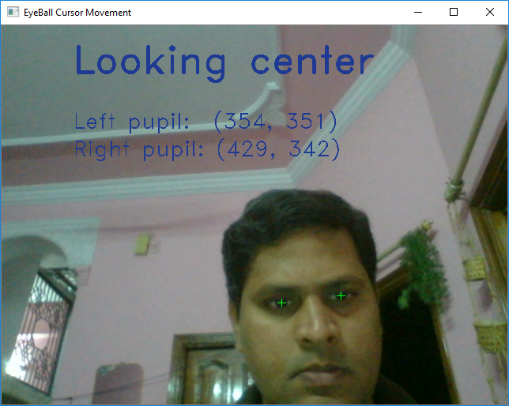

In above screen you can see cursor moves based on eye ball movement. Exception will raise and window close if u move cursor close corners of the screen